Recommendation Report

## **Introduction:**

It is a common problem in industry and academics during the COVID-19 pandemic to be able to communicate both safely and effectively. The problem of safety can easily be fixed with the use of virtual meetings or messaging such as text or video chat. However, our question that we are trying to answer is, what would be the best technology to use to most effectively collaborate as a team in order to complete school assignments, have business meetings, conferences, and virtual interviews?

We have tried to come to a conclusion of this problem through thorough research on each platform, testing each platform, and trying to stay within a reasonable college student research budget. After three weeks of testing and meeting and communicating in groups using these technologies we have come to a conclusion. In this report we will tell you how and why we came to the conclusion we did of what would be the best technology to use to be able to most effectively collaborate as a team in order to complete school assignments, have business meetings, conferences, and virtual interviews.

## **Methods:**

In pursuit of finding which piece of communication technology would work best for a team, we tested a wide range of devices and mediums to see which were effective and which failed to meet the needs of effective communication.

##### The communication technologies that were tested:

|  |  |
| --- | --- |
| Text  Phone Calls  E-mail  Skype  Zoom | Discord  Slack  Google Hangouts  Microsoft Teams |

During each technology’s test, the effectiveness of said technology was rated in several different areas using a scale of 1-10, 1 being the least favorable or effective and 10 being the greatest or most useful in communicating with a team. The areas that each technology were graded in were:

* Response Times
* Quality of conversation
* Ability to share different types of media or visuals
* Recorded history stored in the communication device
* Overall Experience

After completion of the test a list of pros and cons was generated for each device to give a more detailed view of the experience of each technology. These pros and cons were discussed by both individuals on each side of the medium used and made a more direct analysis for each technology.

## **Results:**

Each test was able to be performed on the week of Monday June 28th. These tests took place over an approximate 15-30 minutes with 4 testers, one being a control, for each platform. This gives the total man hour cost to approximately $50 for each test. This gives the total cost of research to a total of $550.

## Text

*Table 1. Evaluation Text With a Score of 0-10*

|  |  |  |  |  |  |
| --- | --- | --- | --- | --- | --- |
| Response times  1-10 | Quality of conversation  1-10 | Ability to provide visuals and other outside material  1-10 | Ability to look back on discussions  1-10 | Overall experience  1-10 | Total Rating |
| 4 | 7 | 8 | 10 | 8 | 37/50 |

Our results gave texting an overall score of 37 out of 50. We found that the biggest weaknesses of texting for a group conference is that the response is not always in a timely manner and not always in sequence with people responding to older messages before reading the newest. The other weakness is it can be hard to convey large or complex information through text without being able to use vocal tones and limited visual aids. The strong suits were found in the ability to be able to look back on whole conversations as well as being able to have a fairly quick conversation without needing to use larger software on a PC that may take more time or resources to load to send a short message. Overall, we came to a conclusion that text is a very good resource to use for it's availability and ease of use, if only minimal information needs to be conveyed such as small questions or setting up further meetings.

## Phone Calls

*Table 2. Evaluation Phone Calls With a Score of 0-10*

|  |  |  |  |  |  |
| --- | --- | --- | --- | --- | --- |
| Response times  1-10 | Quality of conversation  1-10 | Ability to provide visuals and other outside material  1-10 | Ability to look back on discussions  1-10 | Overall experience  1-10 | Total Rating |
| 10 | 6 | 2 | 1 | 7 | 26/50 |

Our group's test gave phone calls a score of 26 out of 50. We found that phone calls have multiple weaknesses for being able to communicate in a group meeting. The biggest weakness we found is that you cannot really look back on the conversations. You could possibly record the conversation and relisten to the whole thing but it is not very intuitive. The other large drawback of using a phone call is there is not really a way to share and use other media types like sharing files or showing pictures to aid in discussions. The one strength of phone calls is that you are able to communicate very fast and without much need. In the end phone calls are not optimal for most large discussions in a group but they have their uses for discussions that may be more in depth then what would be discussed over text.

## E-mail

*Table 3. Evaluation Email With a Score of 0-10*

|  |  |  |  |  |  |
| --- | --- | --- | --- | --- | --- |
| Response times  1-10 | Quality of conversation  1-10 | Ability to provide visuals and other outside material  1-10 | Ability to look back on discussions  1-10 | Overall experience  1-10 | Total Rating |
| 2 | 5 | 9 | 10 | 6 | 32/50 |

In our group test we found email to have an overall score of 32 out of 50. The major drawback of email, and a commonly known one, is the communication time that goes with email. It is fairly well known that with email when you send one it can take up to a couple of days even for someone to respond, if ever. However, if the communication time is kept short, email can be a fairly good form of communication. Emails are good in the ability to look back at specific conversations as well as being able to send various forms of media including text files, images, sound files, etc. After testing we would definitely recommend email for group communication but it would be best kept for sending files, setting up times for other conferences, and exchanging large amounts of information at one time.

## Skype

*Table 4. Evaluation Skype With a Score of 0-10*

|  |  |  |  |  |  |
| --- | --- | --- | --- | --- | --- |
| Response times  1-10 | Quality of conversation  1-10 | Ability to provide visuals and other outside material  1-10 | Ability to look back on discussions  1-10 | Overall experience  1-10 | Total Rating |
| 10 | 7 | 9 | 6 | 7 | 39/50 |

In the test live conversation was found to be extremely useful. The ability to communicate instantly while still remaining remote was very effective in meeting the needs of group work. Skype has shown to be commonly used over the years and is a medium employed by many companies today. One of the major drawbacks that skype has compared to other media platforms is that in Skype you are not as easily able to share media as you would with other telecommunication software. This is a major hindrance considering the fact that most groups share group work and could benefit from an easy file transfer software built into the system instead of having to use a 3rd party program and have multiple types of software open on a single computer which can lead to overloading and sometimes crashing of computer systems.

Group testing gave Skype a total score of 39/50. Although the response time was scored at a 10 the other scores were closer to the 7 mark giving the overall experience an 8. Skype is a useful product but still has its limitations and if it were to expand on its ability file share and its overall record keeping of the video chat it would be a lot better.

## Zoom

*Table 5. Evaluation Zoom With a Score of 0-10*

|  |  |  |  |  |  |
| --- | --- | --- | --- | --- | --- |
| Response times  1-10 | Quality of conversation  1-10 | Ability to provide visuals and other outside material  1-10 | Ability to look back on discussions  1-10 | Overall experience  1-10 | Total Rating |
| 10 | 7 | 10 | 6 | 8 | 41/50 |

Zoom is a video conferencing software program that allows people to meet in a “room” and discuss group topics. It has a built in chat service and the ability to record meetings for later use and reference. It also has built-in host control functions that allow the group leader to control and set the limits of the group. It also gives the ability for a single user or multiple users to share their screen so that there is no need to send files that will be looked at one time and then discarded. Although the conversations can be choppy and whoever is host has to have stellar internet otherwise they could drop from the meeting, Zoom tends to be a highly favored software amongst schools and colleges. It has both a free version and a subscription version that allows for use of individual rooms which can be handy in large companies with many departments.

Group testing gave Zoom and overall experience of 41 out of 50. The two major drawbacks for this communication medium was the inability to review previous discussion history (unless you manually recorded it) and the amount of bandwidth the software monopolizes when in use. It is almost a must to have a wired connection in order to maintain connectivity to the room. If you were to pay the additional subscription cost instead of the free one you may get better connections but it is still at a price. Although Zoom does have a mobile app, it tends to be unstable and have many issues with its connectivity.

## Discord

*Table 6. Evaluation Discord With a Score of 0-10*

|  |  |  |  |  |  |
| --- | --- | --- | --- | --- | --- |
| Response times  1-10 | Quality of conversation  1-10 | Ability to provide visuals and other outside material  1-10 | Ability to look back on discussions  1-10 | Overall experience  1-10 | Total Rating |
| 10 | 8 | 10 | 7 | 9 | 44/50 |

Discord is a favorite communication medium amongst gamers and streamers. Discord sports over a quarter of a billion users. It lets friends communicate directly via voice,video, or chat and allows users to join servers where larger communities can interact together (Minor). Discord allows for notifications and for servers to be split up into smaller channels allowing groups to communicate without being disturbed.

Group testing for Discord was largely positive with an overall score of 44 out of 50. Although favorable in many areas that were tested, the major issue with Discord is that it is not commonly used in a professional setting. Discord is used by gamers and streamers so much that it directs its marketing to that demographic. Most companies tend to be turned off by what is still traditionally considered a “waste of time” even though it has proven to be quite a good livelihood for professional gamers and streamers.

## Slack

*Table 7. Evaluation Slack With a Score of 0-10*

|  |  |  |  |  |  |
| --- | --- | --- | --- | --- | --- |
| Response times  1-10 | Quality of conversation  1-10 | Ability to provide visuals and other outside material  1-10 | Ability to look back on discussions  1-10 | Overall experience  1-10 | Total Rating |
| 4 | 6 | 5 | 5 | 5 | 25/50 |

Slack is a messaging app that spans across a wide range of devices and platforms (Tillman). Slack is easy to download and is available both on PC and Mobile smartphone. It allows for text chatting, sending of files, videos, and other media. Slack also has a robust menu allowing you to create or join multiple channels.

Group testing for Slack appeared to lack luster over the software. Scoring a measly 25 out of 50 (50% positivity rating), slack claims to have everything a team could need for communicating but delivers very little on that promise. It is easy to download but that is as far as the ease of the software goes. Slack has slow response times and a very limited storage capacity. In use one of the testers stated that it is “buggy and tends to bog down the PC when in use.” It keeps a history but like most chat histories it has a drop off after a certain amount of lines. This means that if you wanted to look back at something that your team discussed a week ago you were out of luck because unless nothing happened between that time and now then the history would have been dropped off. Slack does offer premium paid packages of their software that allows for larger storage capacities but the prices seem to be a little higher than other platforms. This may be due to the fact that Slack is still relatively unknown to most people and is still trying to grow the amount of users they have.

## Google Hangouts

*Table 8. Evaluation Hangouts With a Score of 0-10*

|  |  |  |  |  |  |
| --- | --- | --- | --- | --- | --- |
| Response times  1-10 | Quality of conversation  1-10 | Ability to provide visuals and other outside material  1-10 | Ability to look back on discussions  1-10 | Overall experience  1-10 | Total Rating |
| 9 | 6 | 7 | 6 | 7 | 35/50 |

Google hangouts communication medium is a basic means of communicating. It is easy to use and allows you to carry on long conversations instantaneously. It can be used much like text messaging but you can use it from your computer and your phone both instead of being subject to using one or the other.

Group testing for Google hangouts yielded an overall score of 35 out of 50 for its simple to use interface and instant communication abilities. Its major drawbacks are that it is not very file-sharing friendly and you aren’t able to share screens or other types of media very easily without resorting to extensions or modifications. As a base form of communicating, Google Hangouts is reliable and a quick means of communication with the members of your team without needing to send visuals or files for them to look at.

## Microsoft Teams

*Table 9. Evaluation Microsoft Teams With a Score of 0-10*

|  |  |  |  |  |  |
| --- | --- | --- | --- | --- | --- |
| Response times  1-10 | Quality of conversation  1-10 | Ability to provide visuals and other outside material  1-10 | Ability to look back on discussions  1-10 | Overall experience  1-10 | Total Rating |
| 10 | 8 | 10 | 7 | 9 | 44/50 |

Although it originally started out as a paid software, Microsoft Teams has introduced a free version that far supersedes its competitors. The fact that it’s online platform directly integrates its Microsoft Office 365 with chat software, video sharing, file sharing, and other types of media sharing services (Marvin). It also has a notifications option where you can receive updates from your Teams channel directly to your phone. Microsoft Teams offers a great deal and with a well established company like Microsoft at its back it can deliver a great deal more.

Group test was largely positive for Microsoft Teams and put it right at an even score with Discord at 44 out of 50. It’s response time was great and because it integrates with their Office 365 package, it is optimized for sharing most files. However, because it has only been out for 4 years it can be a little difficult to navigate due to an unfamiliar user interface, which is one of the things Slack advised Microsoft on when CEO Satya Nadella first announced its development in 2016 (Marvin). Microsoft Teams does carry with it a higher level of professionalism with its current interface and is growing in popularity amongst businesses worldwide. It is even so user friendly that it can integrate with a company's current Slack platform and communicate through their platform with little to no problems.

## **Graphics :**

*Figure 1*

*Comparison Between Communication Technologies Response Times*

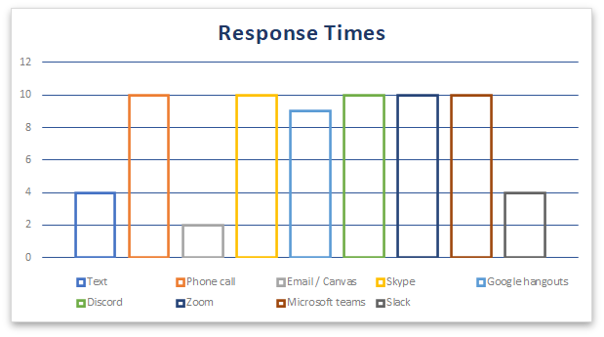

*Figure 2*

*Comparison Between Communication Technologies Quality of Conversation*

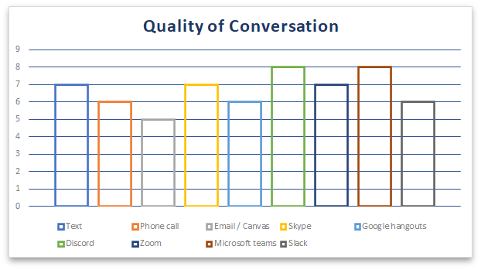

*Figure 3*

*Comparison Between Communication Technologies Ability to Provide Visuals and Other Outside Material*

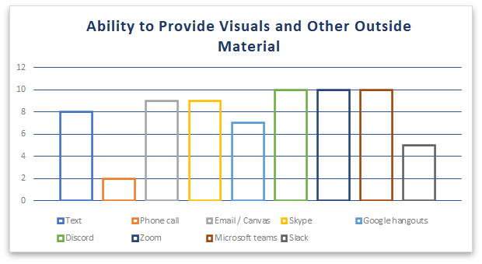

*Figure 4*

*AComparison Between Communication Technologies ability to Look Back on Discussions*

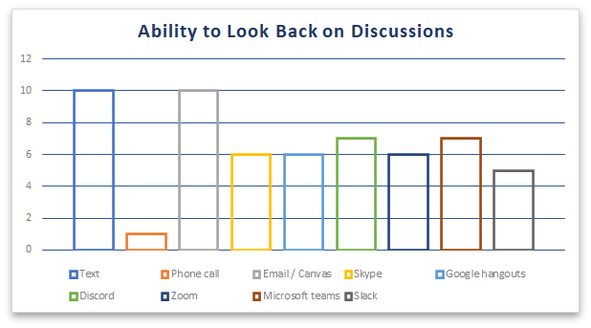

*Figure 5*

*Comparison Between Communication Technologies Overall Experience*

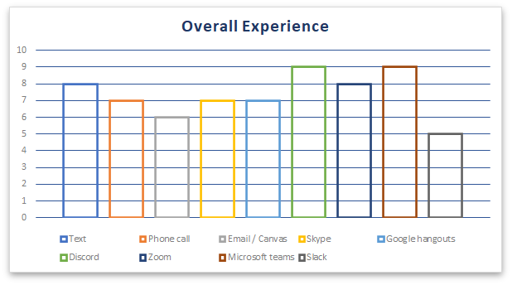

## **Conclusions:**

The overall conclusion we were able to come to in this study is that collaboration spaces such as Microsoft Teams, Discord, and Zoom are the easiest to use and most helpful in being able to most effectively communicate in a group setting. While each communication form has its strengths these collaboration spaces seemed to have the combination of strengths that the others had combined into one location. With this it is also important that these large platforms also have intuitive user interfaces which is why some of the software such as slack and even Zoom did not score as high as they possibly could have based on features.

The last criteria that was not put into our rating system, because of it not being applicable to what we were trying to find, is the professionalism of the software. This is important when things such as communication platforms are considered for companies because it is important to make sure the workspace is kept secure, professional, and has little to no distraction to the work. Because of this last criteria we conclude that the most effective software to use for collaboration in professional and academic settings would be Microsoft Teams. While Discord has almost identical features and even layout as Microsoft Teams, it was also designed and created for communication in the video game entertainment industry. Because of this design, Discord also has many features that cater to a more gaming audience and could be seen as distracting or unprofessional in a work environment.

## **Recommendations:**

As a concluding decision our team would definitely recommend Microsoft Teams as a reliable, easy to use, professional, and efficient communication platform that could be used for school projects, work conferences, interviews, and even everyday communications needed for such things. As a group we would highly recommend the use of Microsoft teams as the official form of communication used in the workplace and in school.

In the workplace this is definitely an easy task to do by simply moving all forms of communication over a span of time from the current platform over to Microsoft Teams and allowing your employees to get used to and familiar with the platform before making it the official means of communication within the company.

In the academic realm it is a little bit harder to regulate student communications when they are working with teams on their own time and accord. However, it is always possible and could be helpful to simply recommend this form of communication to your students in order for them to use it. One incentive to help them to use it is to create a channel specifically for their class on Microsoft teams where the teacher can send out reminders, information about assignments, notifications, etc.Microsoft Teams could even be used to set up study groups, QAs, tutoring, etc. for the class and allows not only the student to have a central location to communicate with classmates and get help, but also the teacher to be able to manage and centralize all the different classroom communications they may have for multiple classes.

Bibliography

Marvin, Rob. “Microsoft Teams Vs. Slack: What's The Difference?” *pcmag.com*, PC Magazine, 24 January 2019, https://www.pcmag.com/news/microsoft-teams-vs-slack-whats-the-difference. Accessed 5 July 2021.

Minor, Jordan. “What Is Discord and How Do You Use It?” *PcMag.com*, PC Magazine, 11 May 2020, https://www.pcmag.com/how-to/what-is-discord-and-how-do-you-use-it. Accessed 5 July 2021.

Tillman, Maggie. “What is Slack and how does it work? Plus plenty of Slack tips and tricks.” *Pocket-Lint.com*, Pocket-Lint, 7 April 2021, https://www.pocket-lint.com/apps/news/150925-what-is-slack-and-how-does-it-work-tips-tricks. Accessed 5 July 2021.

Microsoft. (n.d.). *Video: What is Skype for Business?* Video: What is Skype for Business? - Skype for Business. https://support.microsoft.com/en-us/office/video-what-is-skype-for-business-3a21eca4-434d-41f1-ab06-3d4a268573b7. Accessed 5 July 2021.

WBT Systems. (n.d.). *How Your Association Can Use Zoom for Professional Development*. How Your Association Can Use Zoom for Professional Development | WBT Systems. https://www.wbtsystems.com/learning-hub/blogs/zoom-for-professional-development. Accesses 5 July 2021.